**1. Epic**

* **Definition:** The highest-level work item. Represents a **large business initiative** or goal that may span across multiple sprints or even months.
* **Example:** **“Payment System for the E-commerce app.”**
* An Epic can be broken down into **Features**.

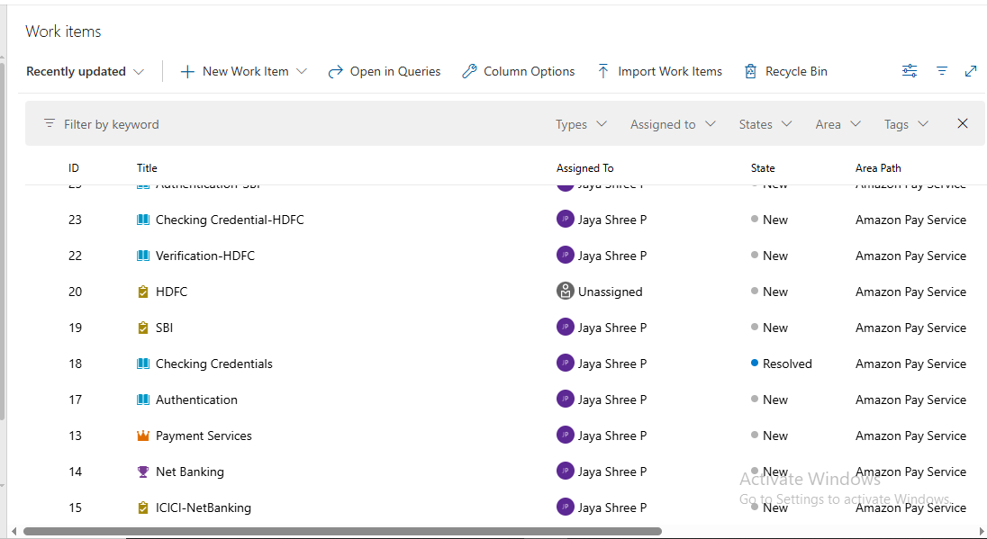

**2. Feature**

* **Definition:** A significant piece of functionality that contributes to fulfilling an Epic.
* **Example:** Under the Online Payment System Epic, a Feature could be:
  + **“Net Banking”**
  + **“UPI Banking”**
  + **“Cash On Delivery”**
* A Feature is further broken into **User Stories**.

| **ID** | **Title** | **Assigned To** | **State** | **Area Path** | **Tags** | **Comments** |
| --- | --- | --- | --- | --- | --- | --- |
| [14](https://dev.azure.com/Jayashree-Training/Amazon%20Pay%20Service/_workitems/edit/14/) | Net Banking | Jaya Shree P | New | Amazon Pay Service |  | 0 |
| [34](https://dev.azure.com/Jayashree-Training/Amazon%20Pay%20Service/_workitems/edit/34/) | Cash On Delivery | Jaya Shree P | New | Amazon Pay Service |  | 0 |
| 35 | UPI Transaction | Jaya Shree P | New | Amazon Pay Service |  | 0 |

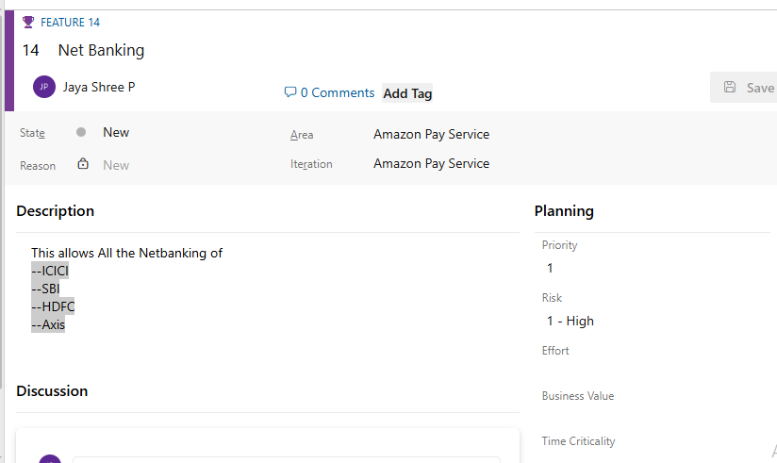

**3. User Story (or Product Backlog Item)**

* **Definition:** Represents a **requirement or functionality** from the end-user perspective. Written in simple language (often in Agile format: “As a [user], I want [functionality] so that [benefit]”).
* **Example:** For the “Connecting with SBI “
* **A User Story is broken down into Tasks .**

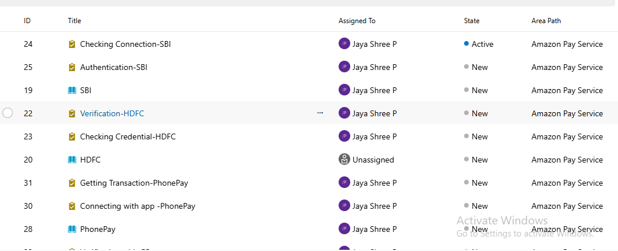

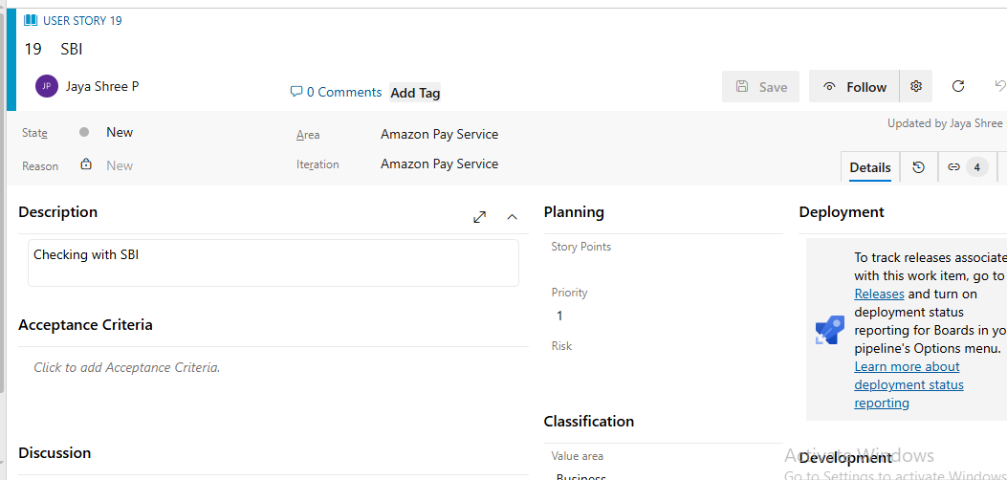

**4. Task**

* **Definition:** The **smallest unit of work**. It describes specific development, testing, or configuration steps needed to complete a User Story.
* **Example:** For the “Save Card Details” User Story:
  + **“Checking Connection.”**
  + **“Authentication”**
  + **“Verifying Credentials**.”
* 

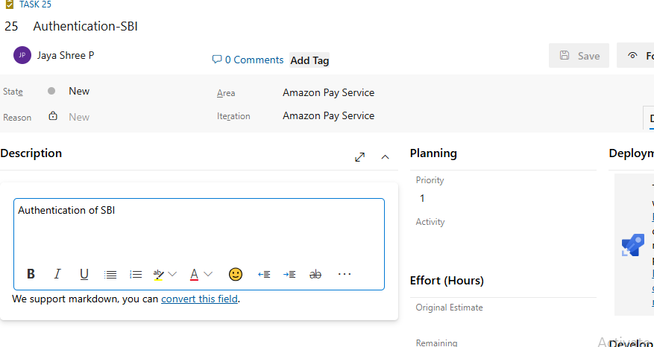

**4. Summary**

* **Epic:** Payment System
  + **Feature:** Online Payment
    - **User Story:** As a customer, I want to use my UPI apps.
      * **Task:** Checking Details
      * **Bug:** Card info not encrypted properly.
      * **Test Case:** Verify card saving and encryption works correctly.

